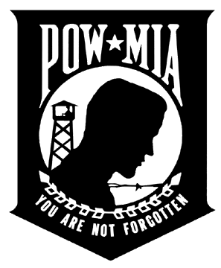

Commander Miguel Garcia
Vice Commander Joe Maichle
Vice Commander Randy Whisman
Al5thdistrict.org
www.facebook.com/al5thdistrictfl/

5th District Meeting at Post 129 (Sunday, December 10, 2023)

I. Call to Order, Commander
II. Opening Ceremonies, Commander/Chaplain/Sgt-at-Arms/Adjutant (Roll Call) Minutes
III. Introduction of Guests/ District Officers
Vice Commander Joe Maichle
Vice Commander Randy Whisman
Adjutant Deveron Reaves
Assistant Adjutant Sonny Kirkwood
Finance Officer Nancy Senter
Chaplain Brian Hancher
Historian-Toshiko Moultrie
Judge Advocate Troy Horsley
Sgt-at-Arms Walter Rasco & Tim Pratt
Service Officer Edgardo Silva
.

IV. Introduction of Chairpersons -
A) AL Riders - Zane Koonce I) FHP Academy- Commander Robert Brewster
B) Americanism- Commander Robert Brewster J) Law & Order- Comrade Barry Litsky
C) Baseball – Comrade Mark Wolford K) Oratorical -Comrade Cindy Anderson
D) Boy Scout- Commander Joe Maichle L) POW / MIA – Comrade Denny Luke
E) Boys State- Comrade Michael Flannagan M) SAL District Commander- SAL Commander Walter Rasco
F) Blood Donor- Comrade Mark Wolford N) School Medals- Comrade Devron Reaves
G) Children & Youth- Commander Lena Heredia-Perez O) Shooting Sports- (Vacant)
H) Disaster Preparedness- Comrade Shawn Beal P) Social Media- Virna Luke

V. Finance Report – Finance Officer Nancy Senter
VI. District Picnic / Hospitality Room - Vice Commander Randy Whisman
VII. Membership – Vice Commander Joe Maichle
VIII. Commander's Report
IX. Post Reports (Should be written & submitted to the Adjutant to include Membership percentage & Post Upcoming Events)
X. Business for the Good of the Legion
XI Ugly Sweater Contest
XII. Closing Ceremony Commander / Chaplain/ Sgt at Arms

UPCOMING EVENTS

Florida Legion College – December 14th – 17th
Northern Area Ball – January 13th, 2024

